UNITED STATES
SECURITIES AND EXCHANGE COMMISSION
WASHINGTON, D.C. 20549

FORM 8-K

CURRENT REPORT
Pursuant to Section 13 or 15(d)
of the Securities Exchange Act of 1934
Date of Report (Date of earliest event reported): May 15, 2026

CANDEL THERAPEUTICS, INC.
(Exact name of Registrant as Specified in Its Charter)

Delaware |  | 001-40629 |  | 52-2214851
(State or Other Jurisdiction  of Incorporation) |  | (Commission  File Number) |  | (IRS Employer  Identification No.)

117 Kendrick St., Suite 450
Needham, MA |  |  |  | 02494
(Address of Principal Executive Offices) |  |  |  | (Zip Code)
Registrant’s Telephone Number, Including Area Code: (617) 916-5445
Not Applicable
(Former Name or Former Address, if Changed Since Last Report)

Check the appropriate box below if the Form 8-K filing is intended to simultaneously satisfy the filing obligation of the registrant under any of the following provisions:

☐ | Written communications pursuant to Rule 425 under the Securities Act (17 CFR 230.425)

☐ | Soliciting material pursuant to Rule 14a-12 under the Exchange Act (17 CFR 240.14a-12)

☐ | Pre-commencement communications pursuant to Rule 14d-2(b) under the Exchange Act (17 CFR 240.14d-2(b))

☐ | Pre-commencement communications pursuant to Rule 13e-4(c) under the Exchange Act (17 CFR 240.13e-4(c))
Securities registered pursuant to Section 12(b) of the Act:

Title of each class |  | Trading  Symbol(s) |  | Name of each exchange  on which registered
Common Stock, $0.01 par value per share |  | CADL |  | The Nasdaq Global Market
Indicate by check mark whether the registrant is an emerging growth company as defined in Rule 405 of the Securities Act of 1933 (§ 230.405 of this chapter) or Rule 12b-2 of the Securities Exchange Act of 1934 (§ 240.12b-2 of this chapter).
Emerging growth company ☒
If an emerging growth company, indicate by check mark if the registrant has elected not to use the extended transition period for complying with any new or revised financial accounting standards provided pursuant to Section 13(a) of the Exchange Act. ☐

Item 7.01 | Regulation FD Disclosure.
On May 15, 2026, Candel Therapeutics, Inc. (the “Company”) held an investor presentation via live webcast to review extended follow-up data from the phase 3 clinical trial of aglatimagene besadenovec in localized prostate cancer, which was also presented by the Company during the American Urological Association 2026 Annual Meeting on May 15, 2026.
A copy of the investor presentation is furnished as Exhibit 99.1 to this Current Report on Form 8-K and incorporated by reference herein. The presentation will also be available on the investor relations section of the Company’s website at https://ir.candeltx.com/. Information contained on the Company’s website is not incorporated by reference into this Current Report on Form 8-K, and you should not consider any information on, or that can be accessed from, the Company’s website as part of this Current Report on Form 8-K.
Also, on May 15, 2026, the Company issued a press release announcing the presentation at the American Urological Association 2026 Annual Meeting. A copy of the full press release is furnished as Exhibit 99.2 to this Current Report on Form 8-K and incorporated by reference herein.
The information in this Item 7.01 and Exhibits 99.1 and 99.2 of this Current Report on Form 8-K are furnished and shall not be deemed to be “filed” for the purposes of Section 18 of the Securities Exchange Act of 1934, as amended (the “Exchange Act”), or otherwise subject to the liabilities of that section. The information in this Item 7.01 and Exhibits 99.1 and 99.2 of this Current Report on Form 8-K shall not be incorporated by reference into any filing under the Securities Act of 1933, as amended, or the Exchange Act, whether made before or after the date of this Current Report on Form 8-K, regardless of any general incorporation language in any such filing.

Item 9.01 | Financial Statements and Exhibits.
(d) Exhibits

Exhibit  Number |  | Description
99.1 |  | Investor Presentation dated May 15, 2026
99.2 |  | Press Release dated May 15, 2026
104 |  | Cover Page Interactive Data File (embedded within the Inline XBRL document)

SIGNATURES
Pursuant to the requirements of the Securities Exchange Act of 1934, the registrant has duly caused this report to be signed on its behalf by the undersigned hereunto duly authorized.

 |  |  |  | Candel Therapeutics, Inc.
Date: May 15, 2026 |  |  |  | By: |  | /s/ Paul Peter Tak
 |  |  |  |  |  | Paul Peter Tak, M.D., Ph.D., FMedSci
 |  |  |  |  |  | President and Chief Executive Officer
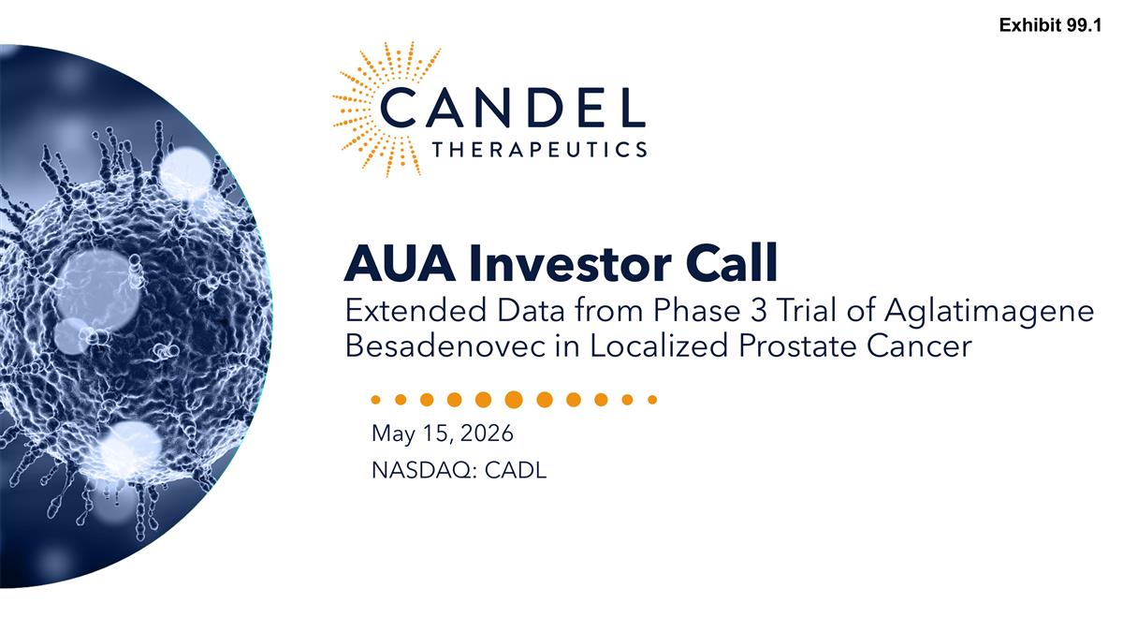
AUA Investor Call Extended Data from Phase 3 Trial of Aglatimagene Besadenovec in Localized Prostate Cancer May 15, 2026 NASDAQ: CADL Exhibit 99.1

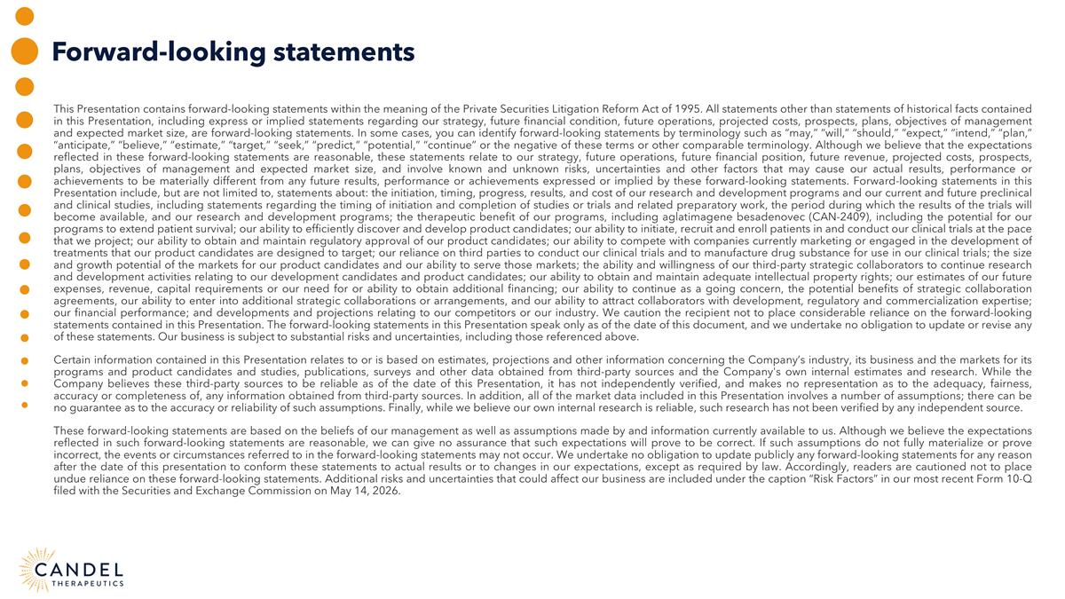
Forward-looking statements This Presentation contains forward-looking statements within the meaning of the Private Securities Litigation Reform Act of 1995. All statements other than statements of historical facts contained in this Presentation, including express or implied statements regarding our strategy, future financial condition, future operations, projected costs, prospects, plans, objectives of management and expected market size, are forward-looking statements. In some cases, you can identify forward-looking statements by terminology such as “may,” “will,” “should,” “expect,” “intend,” “plan,” “anticipate,” “believe,” “estimate,” “target,” “seek,” “predict,” “potential,” “continue” or the negative of these terms or other comparable terminology. Although we believe that the expectations reflected in these forward-looking statements are reasonable, these statements relate to our strategy, future operations, future financial position, future revenue, projected costs, prospects, plans, objectives of management and expected market size, and involve known and unknown risks, uncertainties and other factors that may cause our actual results, performance or achievements to be materially different from any future results, performance or achievements expressed or implied by these forward-looking statements. Forward-looking statements in this Presentation include, but are not limited to, statements about: the initiation, timing, progress, results, and cost of our research and development programs and our current and future preclinical and clinical studies, including statements regarding the timing of initiation and completion of studies or trials and related preparatory work, the period during which the results of the trials will become available, and our research and development programs; the therapeutic benefit of our programs, including aglatimagene besadenovec (CAN-2409), including the potential for our programs to extend patient survival; our ability to efficiently discover and develop product candidates; our ability to initiate, recruit and enroll patients in and conduct our clinical trials at the pace that we project; our ability to obtain and maintain regulatory approval of our product candidates; our ability to compete with companies currently marketing or engaged in the development of treatments that our product candidates are designed to target; our reliance on third parties to conduct our clinical trials and to manufacture drug substance for use in our clinical trials; the size and growth potential of the markets for our product candidates and our ability to serve those markets; the ability and willingness of our third-party strategic collaborators to continue research and development activities relating to our development candidates and product candidates; our ability to obtain and maintain adequate intellectual property rights; our estimates of our future expenses, revenue, capital requirements or our need for or ability to obtain additional financing; our ability to continue as a going concern, the potential benefits of strategic collaboration agreements, our ability to enter into additional strategic collaborations or arrangements, and our ability to attract collaborators with development, regulatory and commercialization expertise; our financial performance; and developments and projections relating to our competitors or our industry. We caution the recipient not to place considerable reliance on the forward-looking statements contained in this Presentation. The forward-looking statements in this Presentation speak only as of the date of this document, and we undertake no obligation to update or revise any of these statements. Our business is subject to substantial risks and uncertainties, including those referenced above. Certain information contained in this Presentation relates to or is based on estimates, projections and other information concerning the Company’s industry, its business and the markets for its programs and product candidates and studies, publications, surveys and other data obtained from third-party sources and the Company's own internal estimates and research. While the Company believes these third-party sources to be reliable as of the date of this Presentation, it has not independently verified, and makes no representation as to the adequacy, fairness, accuracy or completeness of, any information obtained from third-party sources. In addition, all of the market data included in this Presentation involves a number of assumptions; there can be no guarantee as to the accuracy or reliability of such assumptions. Finally, while we believe our own internal research is reliable, such research has not been verified by any independent source. These forward-looking statements are based on the beliefs of our management as well as assumptions made by and information currently available to us. Although we believe the expectations reflected in such forward-looking statements are reasonable, we can give no assurance that such expectations will prove to be correct. If such assumptions do not fully materialize or prove incorrect, the events or circumstances referred to in the forward-looking statements may not occur. We undertake no obligation to update publicly any forward-looking statements for any reason after the date of this presentation to conform these statements to actual results or to changes in our expectations, except as required by law. Accordingly, readers are cautioned not to place undue reliance on these forward-looking statements. Additional risks and uncertainties that could affect our business are included under the caption “Risk Factors” in our most recent Form 10-Q filed with the Securities and Exchange Commission on May 14, 2026.

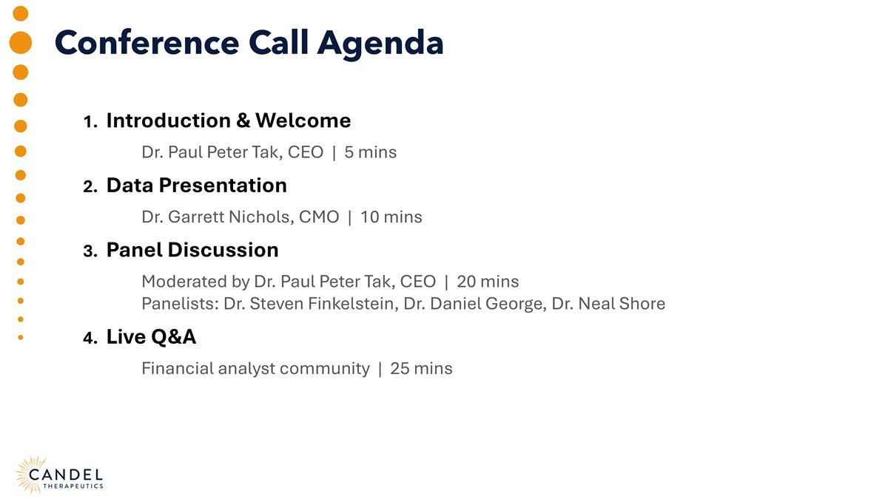
Conference Call Agenda 1. Introduction & Welcome Dr. Paul Peter Tak, CEO | 5 mins 2. Data Presentation Dr. Garrett Nichols, CMO | 10 mins 3. Panel Discussion Moderated by Dr. Paul Peter Tak, CEO | 20 mins Panelists: Dr. Steven Finkelstein, Dr. Daniel George, Dr. Neal Shore 4. Live Q&A Financial analyst community | 25 mins

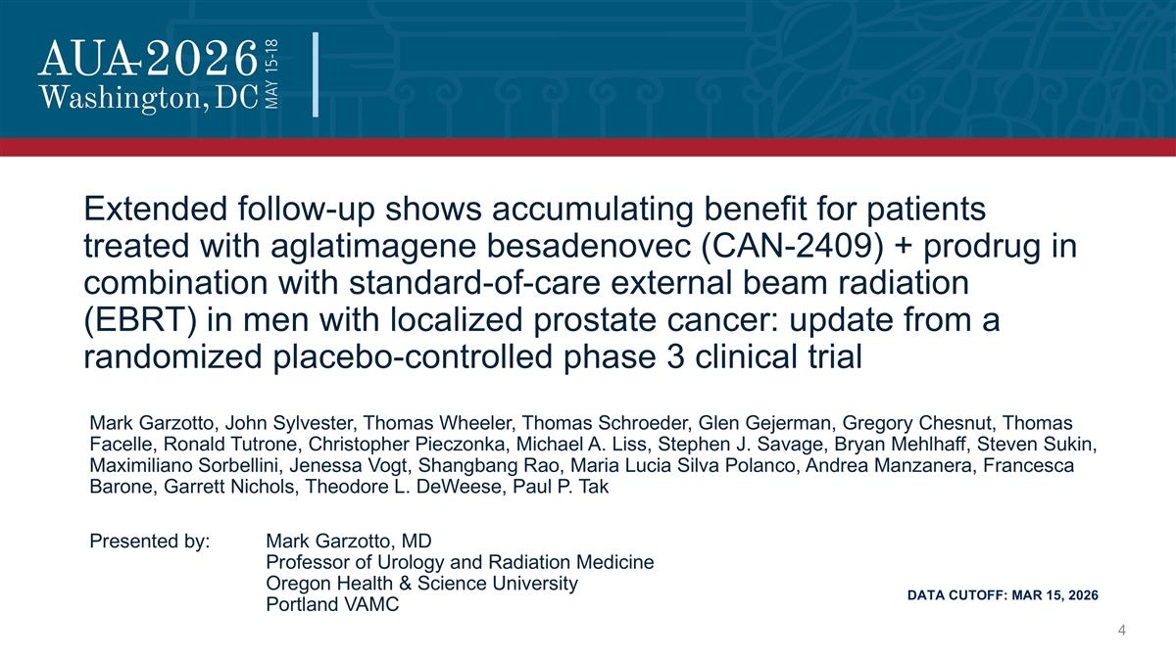
Extended follow-up shows accumulating benefit for patients treated with aglatimagene besadenovec (CAN-2409) + prodrug in combination with standard-of-care external beam radiation (EBRT) in men with localized prostate cancer: update from a randomized placebo-controlled phase 3 clinical trial Mark Garzotto, John Sylvester, Thomas Wheeler, Thomas Schroeder, Glen Gejerman, Gregory Chesnut, Thomas Facelle, Ronald Tutrone, Christopher Pieczonka, Michael A. Liss, Stephen J. Savage, Bryan Mehlhaff, Steven Sukin, Maximiliano Sorbellini, Jenessa Vogt, Shangbang Rao, Maria Lucia Silva Polanco, Andrea Manzanera, Francesca Barone, Garrett Nichols, Theodore L. DeWeese, Paul P. Tak Presented by: Mark Garzotto, MD Professor of Urology and Radiation Medicine Oregon Health & Science University Portland VAMC DATA CUTOFF: MAR 15, 2026

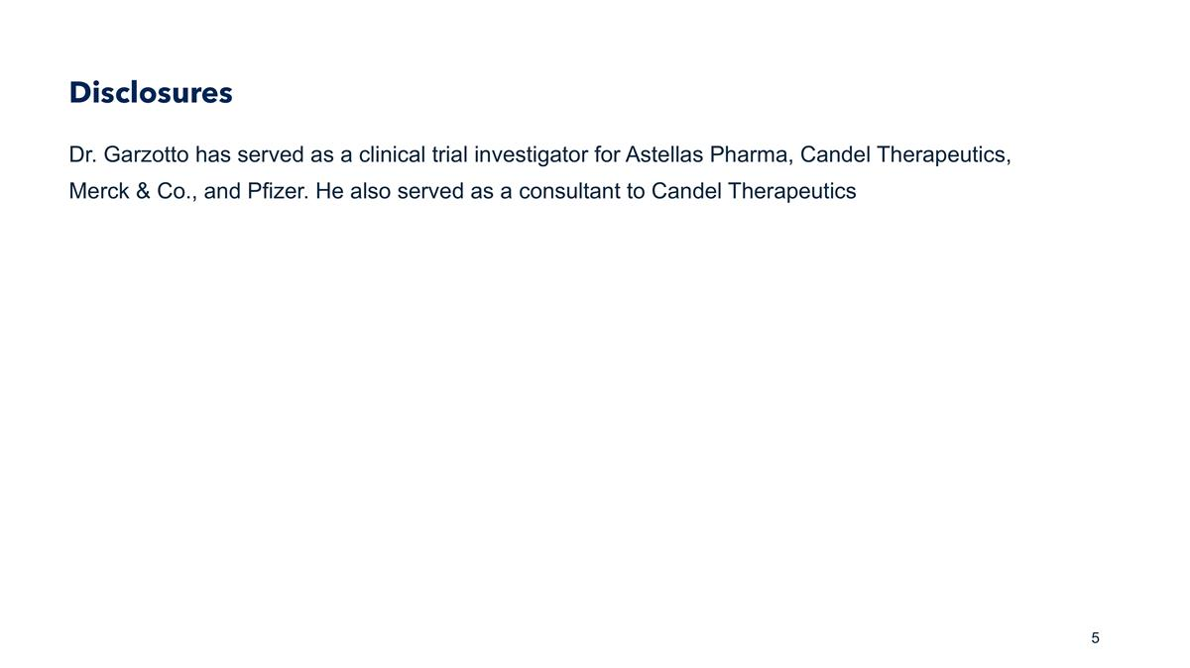
Disclosures Dr. Garzotto has served as a clinical trial investigator for Astellas Pharma, Candel Therapeutics, Merck & Co., and Pfizer. He also served as a consultant to Candel Therapeutics

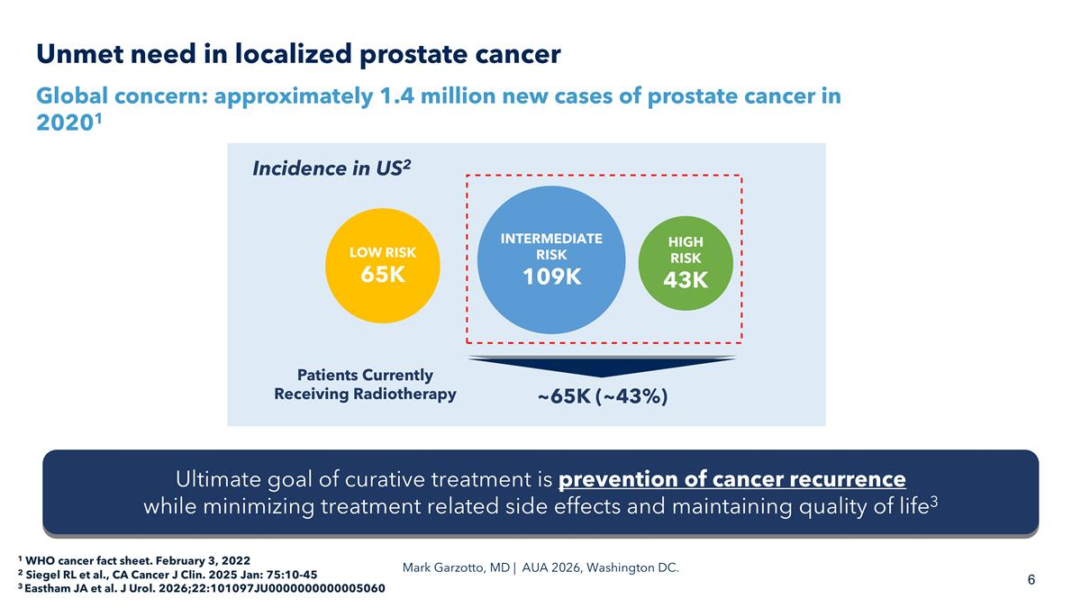
Unmet need in localized prostate cancer Global concern: approximately 1.4 million new cases of prostate cancer in 20201 1 WHO cancer fact sheet. February 3, 2022 2 Siegel RL et al., CA Cancer J Clin. 2025 Jan: 75:10-45 3 Eastham JA et al. J Urol. 2026;22:101097JU0000000000005060 LOW RISK 65K INTERMEDIATE RISK 109K HIGH RISK 43K ~65K (~43%) Incidence in US2 Patients Currently Receiving Radiotherapy Ultimate goal of curative treatment is prevention of cancer recurrence while minimizing treatment related side effects and maintaining quality of life3 Mark Garzotto, MD | AUA 2026, Washington DC.

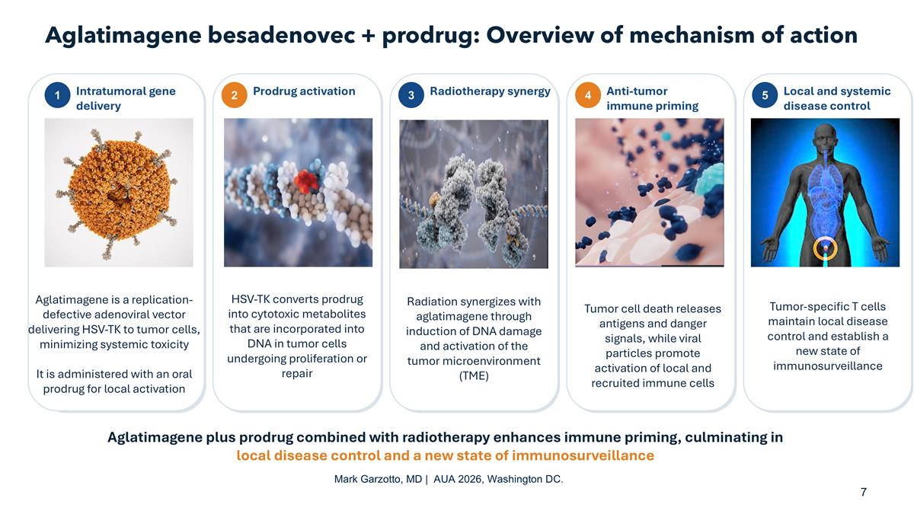
Aglatimagene besadenovec + prodrug: Overview of mechanism of action 1 Intratumoral gene delivery Aglatimagene is a replication- defective adenoviral vector delivering HSV-TK to tumor cells, minimizing systemic toxicity It is administered with an oral prodrug for local activation 2 Prodrug activation HSV-TK converts prodrug into cytotoxic metabolites that are incorporated into DNA in tumor cells undergoing proliferation or repair 3 Radiotherapy synergy Radiation synergizes with aglatimagene through induction of DNA damage and activation of the tumor microenvironment (TME) 4 Anti-tumor immune priming Tumor cell death releases antigens and danger signals, while viral particles promote activation of local and recruited immune cells 5 Local and systemic disease control Aglatimagene plus prodrug combined with radiotherapy enhances immune priming, culminating in local disease control and a new state of immunosurveillance 5 Local and systemic disease control Tumor-specific T cells maintain local disease control and establish a new state of immunosurveillance Mark Garzotto, MD | AUA 2026, Washington DC.

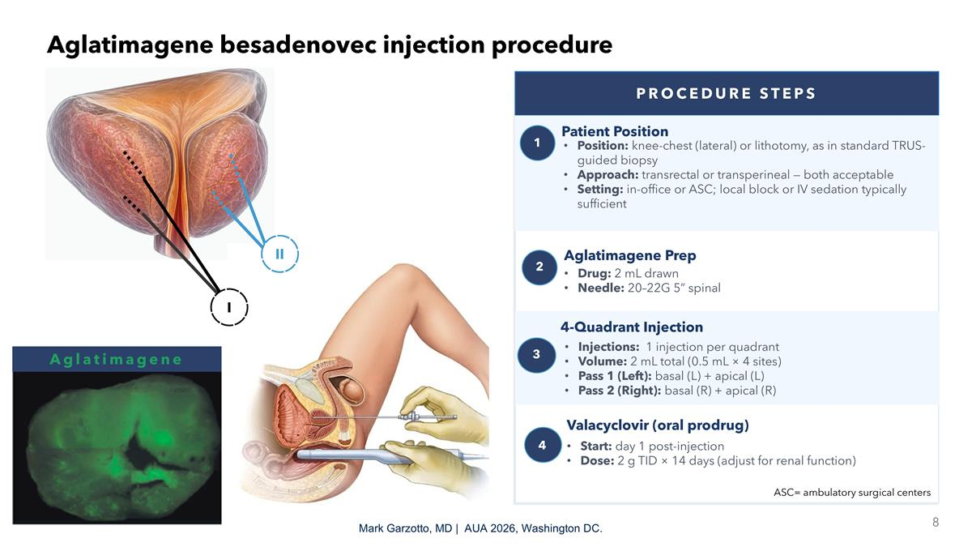
Aglatimagene besadenovec injection procedure PROCEDURE STEPS 1 Patient Position Position: knee-chest (lateral) or lithotomy, as in standard TRUS-guided biopsy Approach: transrectal or transperineal — both acceptable Setting: in-office or ASC; local block or IV sedation typically sufficient 2 Aglatimagene Prep Drug: 2 mL drawn Needle: 20–22G 5” spinal 4 Valacyclovir (oral prodrug) Start: day 1 post-injection Dose: 2 g TID × 14 days (adjust for renal function) ASC= ambulatory surgical centers 4-Quadrant Injection Injections: 1 injection per quadrant Volume: 2 mL total (0.5 mL × 4 sites) Pass 1 (Left): basal (L) + apical (L) Pass 2 (Right): basal (R) + apical (R) 3 I II Mark Garzotto, MD | AUA 2026, Washington DC. Aglatimagene

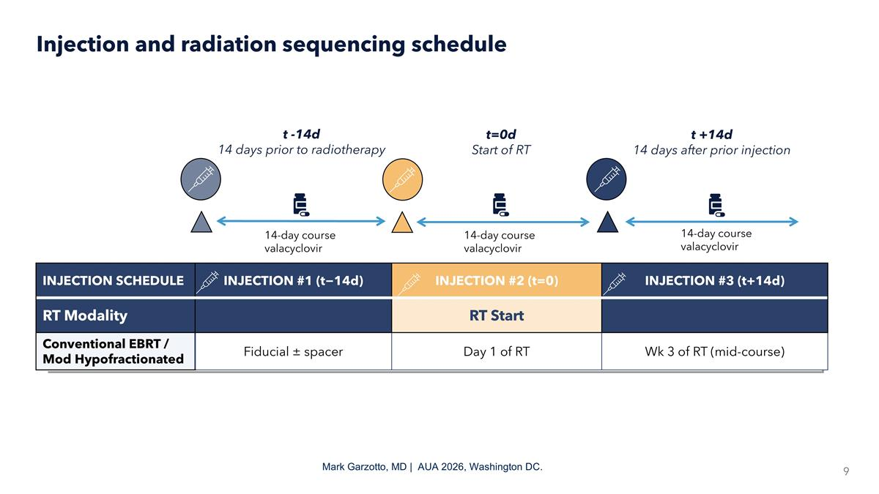
INJECTION SCHEDULE INJECTION #1 (t−14d) INJECTION #2 (t=0) INJECTION #3 (t+14d) RT Modality RT Prep RT Start Ongoing RT Conventional EBRT / Mod Hypofractionated Fiducial ± spacer Day 1 of RT Wk 3 of RT (mid-course) Injection and radiation sequencing schedule t -14d 14 days prior to radiotherapy t=0d Start of RT t +14d 14 days after prior injection 14-day course valacyclovir 14-day course valacyclovir 14-day course valacyclovir Mark Garzotto, MD | AUA 2026, Washington DC.

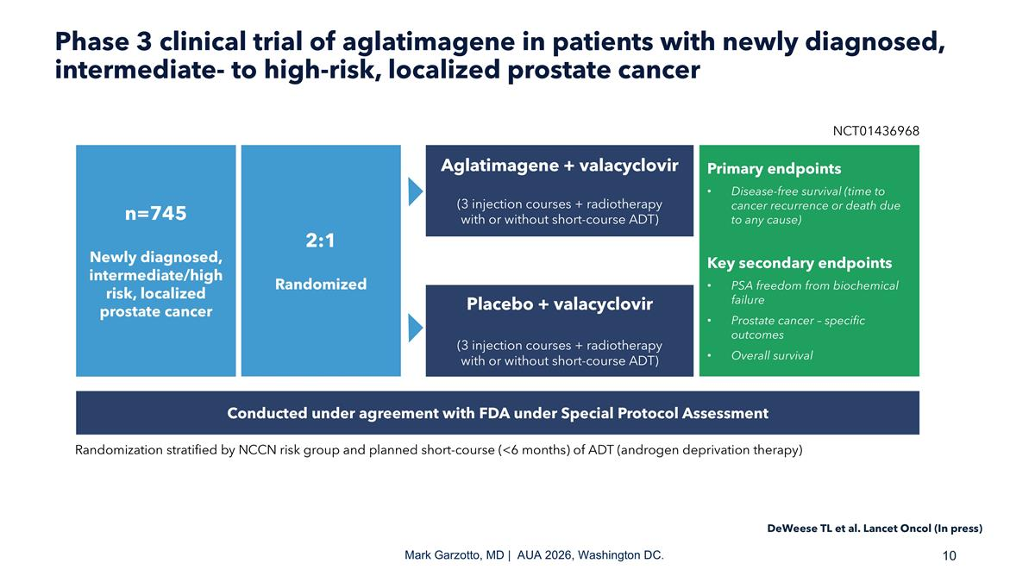
Phase 3 clinical trial of aglatimagene in patients with newly diagnosed, intermediate- to high-risk, localized prostate cancer n=745 Newly diagnosed, intermediate/high risk, localized prostate cancer 2:1 Randomized Aglatimagene + valacyclovir (3 injection courses + radiotherapy with or without short-course ADT) Placebo + valacyclovir (3 injection courses + radiotherapy with or without short-course ADT) Primary endpoints Disease-free survival (time to cancer recurrence or death due to any cause) Key secondary endpoints PSA freedom from biochemical failure Prostate cancer – specific outcomes Overall survival NCT01436968 Conducted under agreement with FDA under Special Protocol Assessment Randomization stratified by NCCN risk group and planned short-course (<6 months) of ADT (androgen deprivation therapy) Mark Garzotto, MD | AUA 2026, Washington DC. DeWeese TL et al. Lancet Oncol (In press)

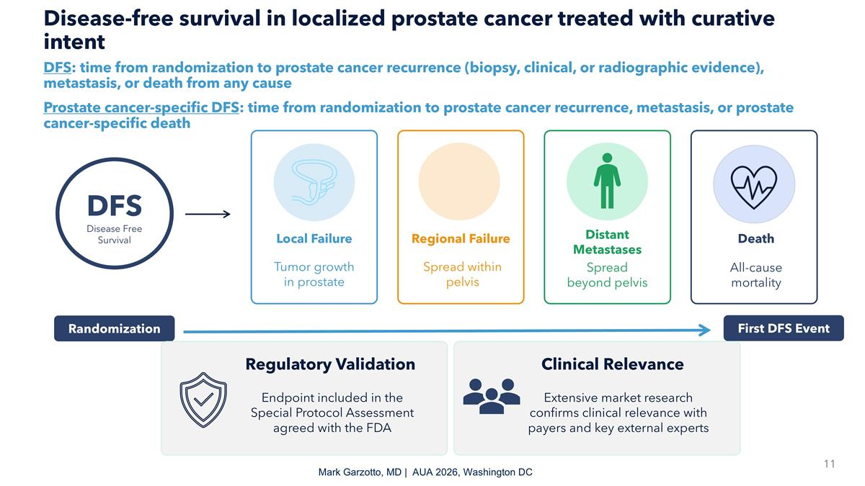
Disease-free survival in localized prostate cancer treated with curative intent DFS: time from randomization to prostate cancer recurrence (biopsy, clinical, or radiographic evidence), metastasis, or death from any cause Prostate cancer-specific DFS: time from randomization to prostate cancer recurrence, metastasis, or prostate cancer-specific death DFS Disease Free Survival Local Failure Tumor growth in prostate Regional Failure Spread within pelvis Distant Metastases Spread beyond pelvis Death All-cause mortality Randomization First DFS Event Endpoint included in the Special Protocol Assessment agreed with the FDA Regulatory Validation Extensive market research confirms clinical relevance with payers and key external experts Clinical Relevance Mark Garzotto, MD | AUA 2026, Washington DC

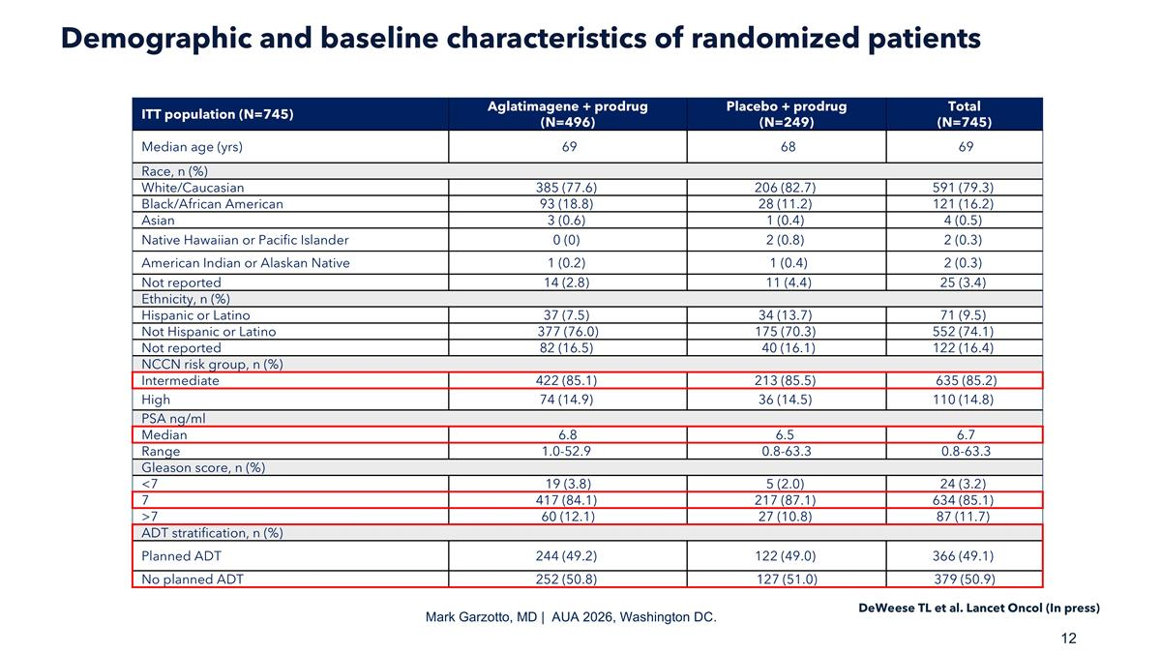
Demographic and baseline characteristics of randomized patients ITT population (N=745) Aglatimagene + prodrug (N=496) Placebo + prodrug (N=249) Total (N=745) Median age (yrs) 69 68 69 Race, n (%) White/Caucasian 385 (77.6) 206 (82.7) 591 (79.3) Black/African American 93 (18.8) 28 (11.2) 121 (16.2) Asian 3 (0.6) 1 (0.4) 4 (0.5) Native Hawaiian or Pacific Islander 0 (0) 2 (0.8) 2 (0.3) American Indian or Alaskan Native 1 (0.2) 1 (0.4) 2 (0.3) Not reported 14 (2.8) 11 (4.4) 25 (3.4) Ethnicity, n (%) Hispanic or Latino 37 (7.5) 34 (13.7) 71 (9.5) Not Hispanic or Latino 377 (76.0) 175 (70.3) 552 (74.1) Not reported 82 (16.5) 40 (16.1) 122 (16.4) NCCN risk group, n (%) Intermediate 422 (85.1) 213 (85.5) 635 (85.2) High 74 (14.9) 36 (14.5) 110 (14.8) PSA ng/ml Median 6.8 6.5 6.7 Range 1.0-52.9 0.8-63.3 0.8-63.3 Gleason score, n (%) <7 19 (3.8) 5 (2.0) 24 (3.2) 7 417 (84.1) 217 (87.1) 634 (85.1) >7 60 (12.1) 27 (10.8) 87 (11.7) ADT stratification, n (%) Planned ADT 244 (49.2) 122 (49.0) 366 (49.1) No planned ADT 252 (50.8) 127 (51.0) 379 (50.9) Mark Garzotto, MD | AUA 2026, Washington DC. DeWeese TL et al. Lancet Oncol (In press)

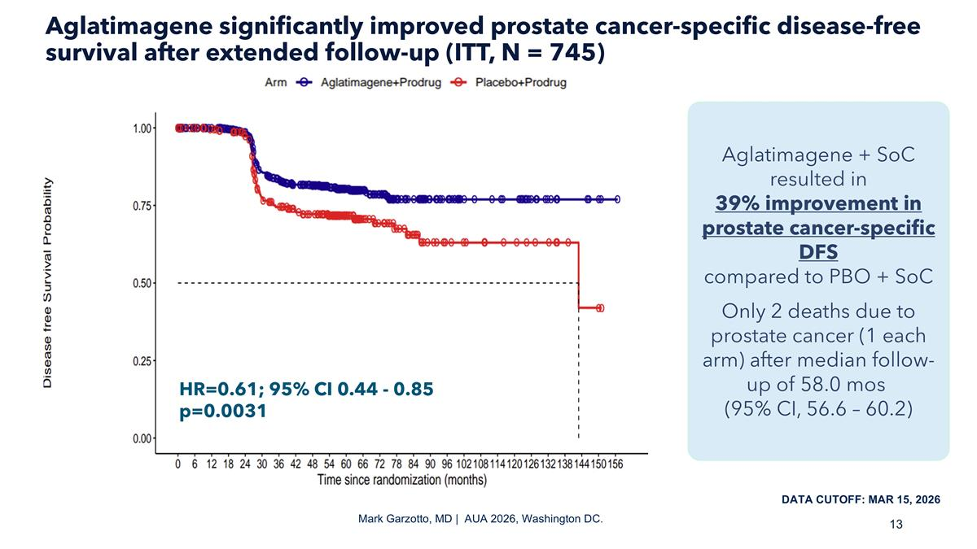
Aglatimagene significantly improved prostate cancer-specific disease-free survival after extended follow-up (ITT, N = 745) Mark Garzotto, MD | AUA 2026, Washington DC. HR=0.61; 95% CI 0.44 - 0.85 p=0.0031 Aglatimagene + SoC resulted in 39% improvement in prostate cancer-specific DFS compared to PBO + SoC Only 2 deaths due to prostate cancer (1 each arm) after median follow-up of 58.0 mos (95% CI, 56.6 – 60.2) DATA CUTOFF: MAR 15, 2026

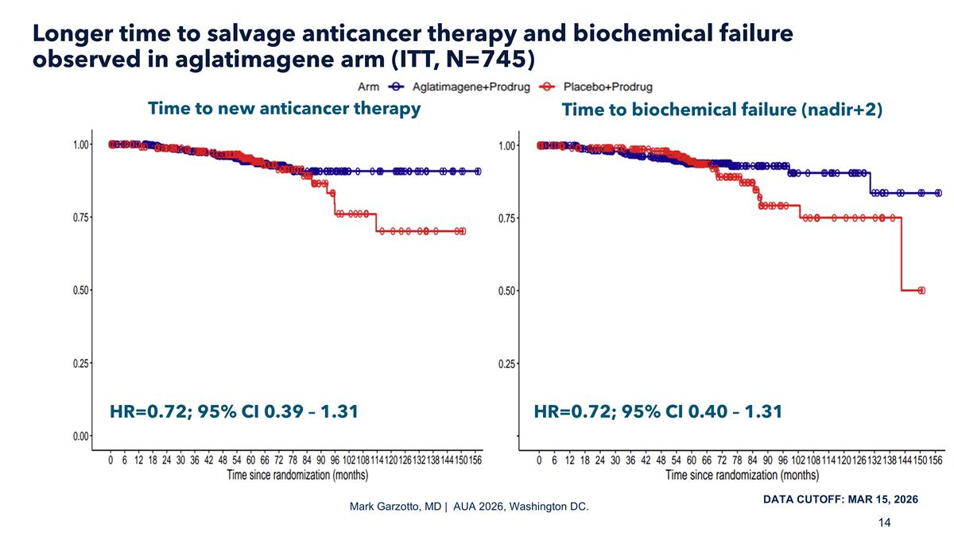
Longer time to salvage anticancer therapy and biochemical failure observed in aglatimagene arm (ITT, N=745) Mark Garzotto, MD | AUA 2026, Washington DC. DATA CUTOFF: MAR 15, 2026 Time to new anticancer therapy Time to biochemical failure (nadir+2) HR=0.72; 95% CI 0.40 – 1.31 HR=0.72; 95% CI 0.39 – 1.31

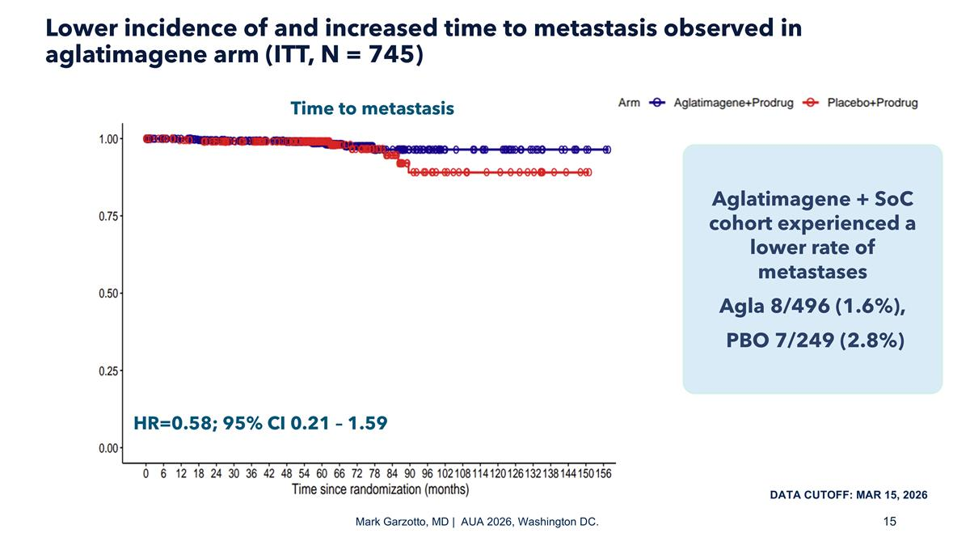
Lower incidence of and increased time to metastasis observed in aglatimagene arm (ITT, N = 745) Mark Garzotto, MD | AUA 2026, Washington DC. Aglatimagene + SoC cohort experienced a lower rate of metastases Agla 8/496 (1.6%), PBO 7/249 (2.8%) DATA CUTOFF: MAR 15, 2026 Time to metastasis HR=0.58; 95% CI 0.21 – 1.59

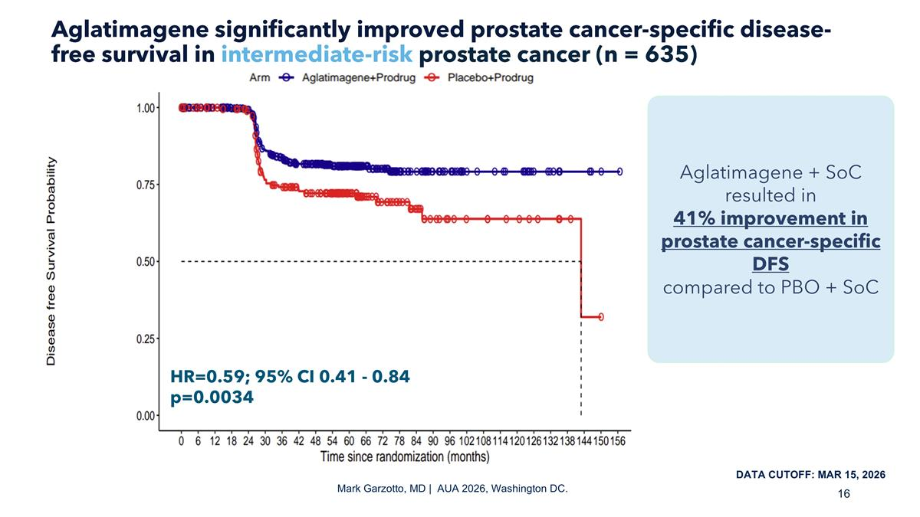
Aglatimagene significantly improved prostate cancer-specific disease-free survival in intermediate-risk prostate cancer (n = 635) Mark Garzotto, MD | AUA 2026, Washington DC. Aglatimagene + SoC resulted in 41% improvement in prostate cancer-specific DFS compared to PBO + SoC DATA CUTOFF: MAR 15, 2026 HR=0.59; 95% CI 0.41 - 0.84 p=0.0034

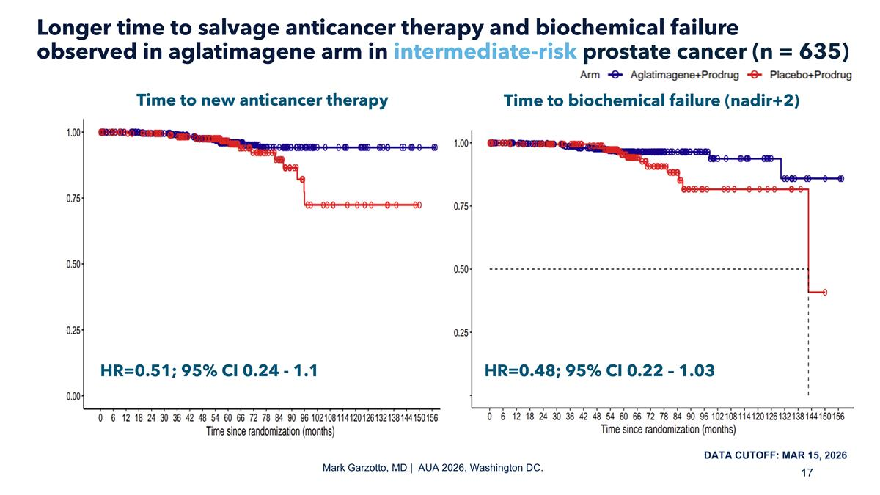
Longer time to salvage anticancer therapy and biochemical failure observed in aglatimagene arm in intermediate-risk prostate cancer (n = 635) Mark Garzotto, MD | AUA 2026, Washington DC. DATA CUTOFF: MAR 15, 2026 HR=0.48; 95% CI 0.22 – 1.03 HR=0.51; 95% CI 0.24 - 1.1 Time to new anticancer therapy Time to biochemical failure (nadir+2)

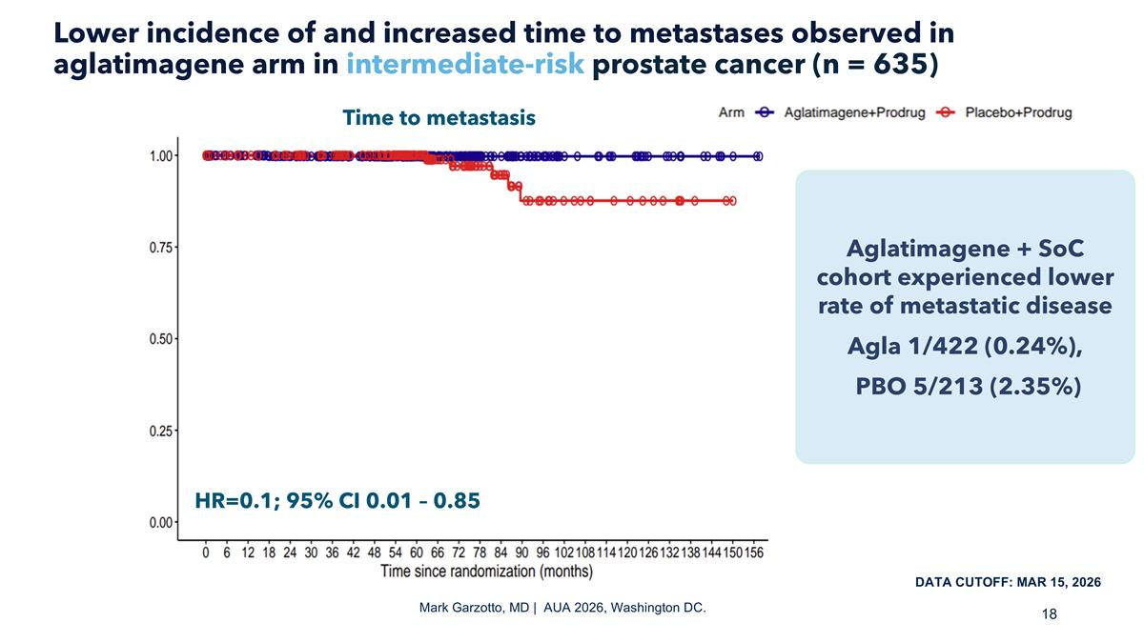
Lower incidence of and increased time to metastases observed in aglatimagene arm in intermediate-risk prostate cancer (n = 635) Mark Garzotto, MD | AUA 2026, Washington DC. Aglatimagene + SoC cohort experienced lower rate of metastatic disease Agla 1/422 (0.24%), PBO 5/213 (2.35%) DATA CUTOFF: MAR 15, 2026 Time to metastasis HR=0.1; 95% CI 0.01 – 0.85

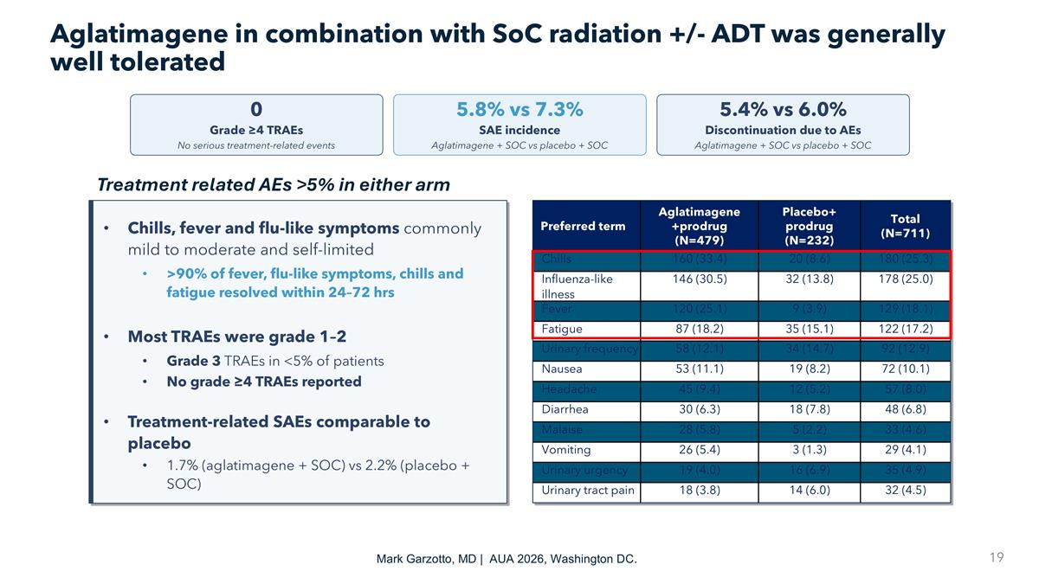
Aglatimagene in combination with SoC radiation +/- ADT was generally well tolerated Treatment related AEs >5% in either arm Chills, fever and flu-like symptoms commonly mild to moderate and self-limited >90% of fever, flu-like symptoms, chills and fatigue resolved within 24–72 hrs Most TRAEs were grade 1–2 Grade 3 TRAEs in <5% of patients No grade ≥4 TRAEs reported Treatment-related SAEs comparable to placebo 1.7% (aglatimagene + SOC) vs 2.2% (placebo + SOC) Preferred term Aglatimagene +prodrug (N=479) Placebo+ prodrug (N=232) Total (N=711) Chills 160 (33.4) 20 (8.6) 180 (25.3) Influenza-like illness 146 (30.5) 32 (13.8) 178 (25.0) Fever 120 (25.1) 9 (3.9) 129 (18.1) Fatigue 87 (18.2) 35 (15.1) 122 (17.2) Urinary frequency 58 (12.1) 34 (14.7) 92 (12.9) Nausea 53 (11.1) 19 (8.2) 72 (10.1) Headache 45 (9.4) 12 (5.2) 57 (8.0) Diarrhea 30 (6.3) 18 (7.8) 48 (6.8) Malaise 28 (5.8) 5 (2.2) 33 (4.6) Vomiting 26 (5.4) 3 (1.3) 29 (4.1) Urinary urgency 19 (4.0) 16 (6.9) 35 (4.9) Urinary tract pain 18 (3.8) 14 (6.0) 32 (4.5) 0 Grade ≥4 TRAEs No serious treatment-related events 5.8% vs 7.3% SAE incidence Aglatimagene + SOC vs placebo + SOC 5.4% vs 6.0% Discontinuation due to AEs Aglatimagene + SOC vs placebo + SOC Mark Garzotto, MD | AUA 2026, Washington DC.

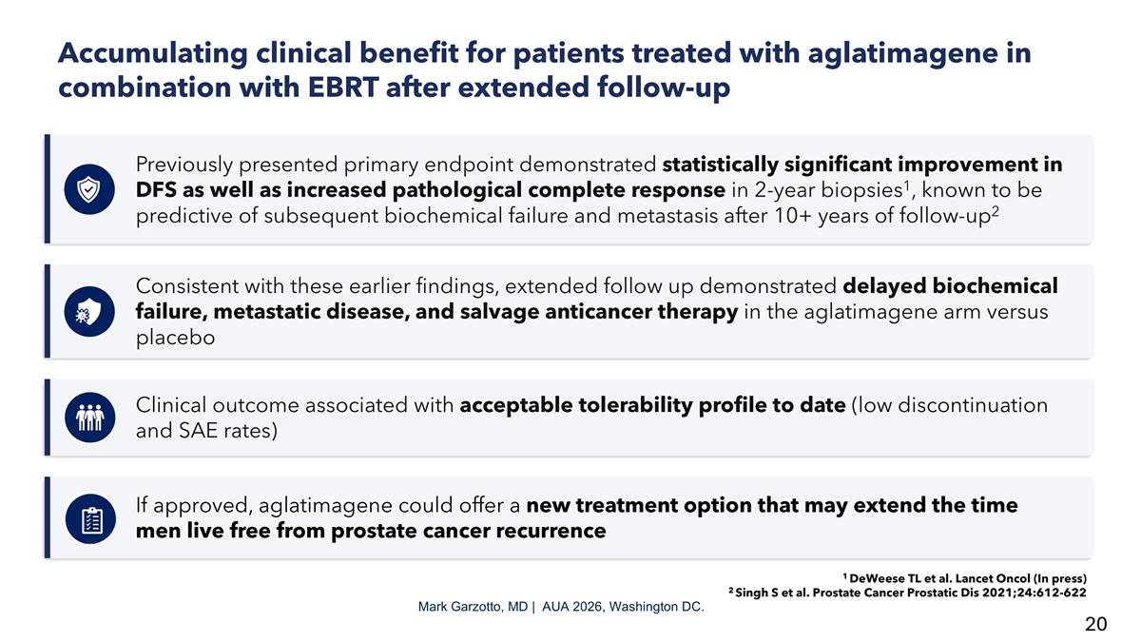
Accumulating clinical benefit for patients treated with aglatimagene in combination with EBRT after extended follow-up Previously presented primary endpoint demonstrated statistically significant improvement in DFS as well as increased pathological complete response in 2-year biopsies1, known to be predictive of subsequent biochemical failure and metastasis after 10+ years of follow-up2 Consistent with these earlier findings, extended follow up demonstrated delayed biochemical failure, metastatic disease, and salvage anticancer therapy in the aglatimagene arm versus placebo Clinical outcome associated with acceptable tolerability profile to date (low discontinuation and SAE rates) If approved, aglatimagene could offer a new treatment option that may extend the time men live free from prostate cancer recurrence Mark Garzotto, MD | AUA 2026, Washington DC. 1 DeWeese TL et al. Lancet Oncol (In press) 2 Singh S et al. Prostate Cancer Prostatic Dis 2021;24:612-622

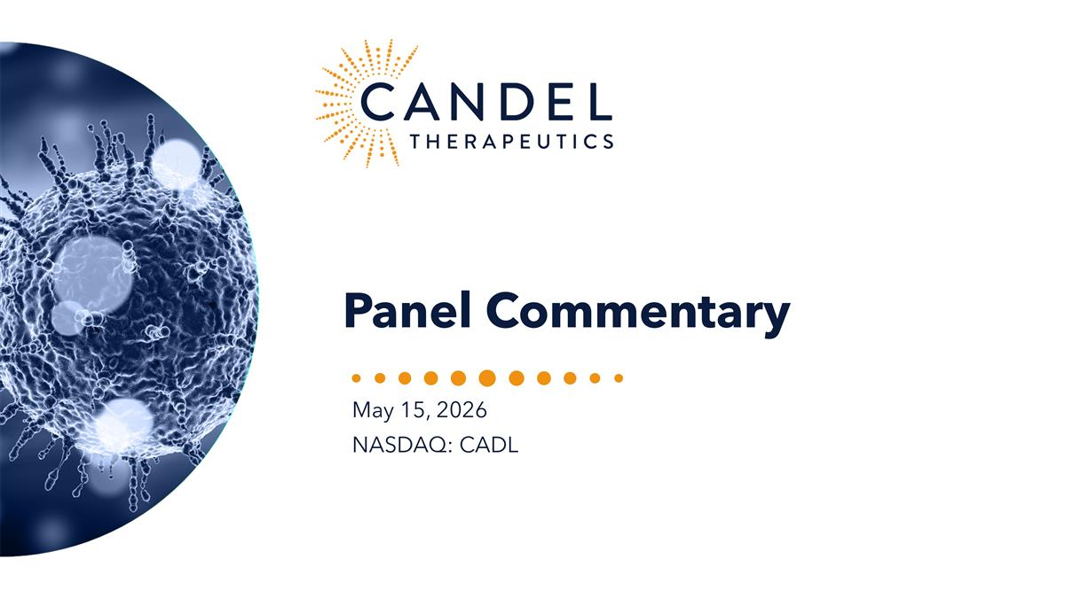
Panel Commentary May 15, 2026 NASDAQ: CADL

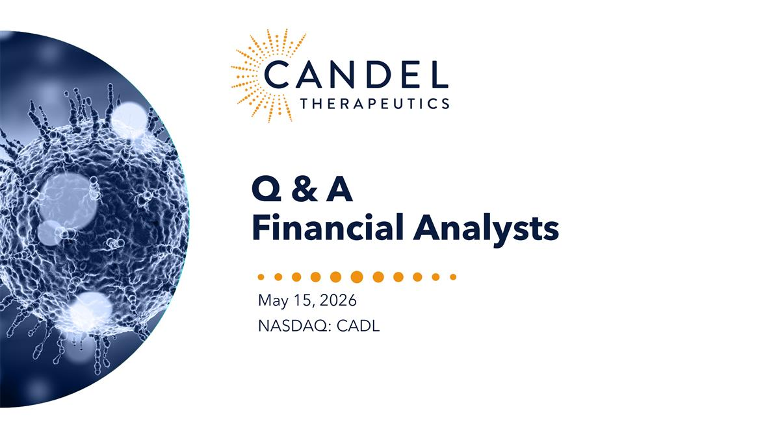
Q & A Financial Analysts May 15, 2026 NASDAQ: CADL

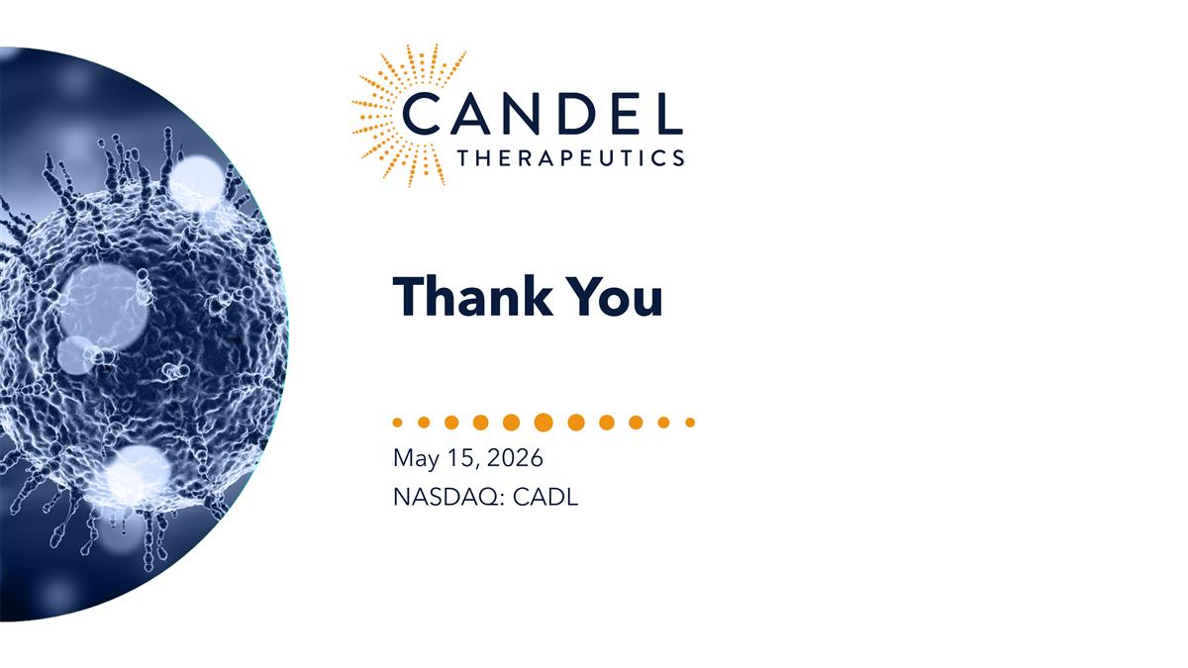
Thank You May 15, 2026 NASDAQ: CADL
Exhibit 99.2


Candel Therapeutics Reports Extended Clinical Benefit Over Multiple Clinical Endpoints in Patients from Phase 3 Trial of Aglatimagene Besadenovec (CAN-2409) in Localized Prostate Cancer Under Prolonged Follow-up at AUA 2026 Annual Meeting

 |  |  | Extended follow-up data from the phase 3 study (20 months after reported topline data, median follow-up 58 months) confirmed a statistically significant and clinically meaningful improvement in prostate cancer–specific disease-free survival (DFS) of 39% after aglatimagene administration compared to placebo, reinforcing the potential of aglatimagene to reduce the risk of tumor recurrence in men receiving radiotherapy for localized disease.

 |  |  | Clinical benefit demonstrated in the intention-to treat (ITT) population by secondary and clinically relevant exploratory endpoints with numerical improvements observed in time to biochemical failure (TTBF), lower incidence of and increased time to metastases, and increased time to salvage anti-cancer treatment (TTNT)

 |  |  | Exploratory analysis within the sub-group of patients with intermediate-risk prostate cancer (85% of the study population) suggested that treatment with aglatimagene plus radiotherapy resulted in a statistically significant 90% reduction in time to metastasis (TTM) versus placebo plus standard-of-care radiotherapy, along with a lower metastasis rate, supporting the potential of aglatimagene to control both local and systemic disease recurrence
NEEDHAM, Mass., May 15, 2026 (GLOBE NEWSWIRE) — Candel Therapeutics, Inc. (Candel or the Company) (Nasdaq: CADL), a clinical-stage biopharmaceutical company focused on developing multimodal immunotherapies to improve disease outcomes for patients with cancer, today announced new results from extended follow-up of its randomized, double-blind, placebo-controlled pivotal phase 3 trial of aglatimagene besadenovec (aglatimagene or CAN-2409) in intermediate- to high-risk localized prostate cancer. These findings demonstrate consistent clinical benefit across multiple exploratory endpoints, reinforcing the positive topline data announced in December 2024 after an additional 20 months of follow-up, with a cutoff date of March 15, 2026.

The data were presented by Mark G. Garzotto, M.D., Professor of Urology and Radiation Medicine at Oregon Health & Science University, during the “Practice-changing, Paradigm-shifting Clinical Trials in Urology” oral plenary session at the American Urological Association (AUA) 2026 Annual Meeting in Washington, D.C.
Key Highlights from AUA 2026 Presentation:
Among the 745 patients enrolled in the randomized, double-blind, placebo-controlled trial, the aglatimagene arm exhibited a 39% improvement in prostate cancer-specific disease-free survival (PCa-specific DFS) compared to placebo (hazard ratio [HR] 0.61; 95% confidence interval [CI]: 0.44, 0.85; p=0.0031) after a median follow-up of 58 months (data as of March 15, 2026). Two prostate cancer-specific deaths occurred (1 in each arm) after median follow-up of less than 10 years.
We observed consistently favorable trends in the ITT population across all secondary and exploratory endpoints, including time to biochemical failure (TTBF; HR 0.72, CI 0.40,1.31), time to metastasis (TTM; HR 0.58, CI 0.21, 1.59), rate of metastasis [(1.6% (8/496) vs. 2.8% (7/249)], and time to salvage anti-cancer therapy (time to new treatment (TTNT) HR 0.72, CI 0.39, 1.31), when comparing the aglatimagene arm with placebo on top of standard-of-care radiotherapy.
Within the intermediate-risk subgroup (635 patients, 85% of the ITT population), the aglatimagene arm demonstrated 41% improvement in PCa-specific DFS (HR 0.59, 95% CI 0.41, 0.84, p=0.0034) relative to placebo. In addition, descriptive analyses showed 52% improvement in TTBF (HR 0.48, CI 0.22, 1.03), 90% improvement in TTM (HR 0.1, CI 0.01, 0.85), lower rate of metastatic disease [0.24% (1/422) vs. 2.35% (5/213)], and 49% improvement in TTNT (HR 0.51, CI 0.24, 1.1), when comparing the aglatimagene arm with the placebo arm.
In December 2024, we reported that aglatimagene significantly improved the rate of pathological complete response in 2-year biopsies compared with placebo, suggesting the cancer had been eradicated at a microscopic level.1 Previously published work has shown that histologic changes precede clinical evidence of recurrence and that prostate biopsies, positive for cancer cells ≥ 2 years after radiotherapy, are predictive of subsequent clinically meaningful outcomes, including biochemical failure and development of metastases.2 While the number of events for biochemical failure and development of metastases presented at AUA is, as expected, still too small to achieve statistical significance for most outcomes, the observed trends are consistent and in line with this published literature, supporting the potentially long-term clinical benefit of aglatimagene. We will continue to monitor the patients over time.

“After prolonged follow-up, these data further demonstrated that aglatimagene delivered a statistically significant and clinically meaningful improvement in prostate cancer–specific disease-free survival, with a 39% reduction in the risk of recurrence,” said Paul Peter Tak, M.D., Ph.D., FMedSci, President and Chief Executive Officer of Candel Therapeutics. “Importantly, we are seeing consistent, favorable trends across multiple clinically relevant secondary and exploratory endpoints, including time to biochemical failure, time to metastasis, and need for subsequent anti-cancer therapy. These findings, combined with earlier evidence of increased pathological complete response at two years, reinforce our confidence that aglatimagene has the potential to deliver durable control of both local and systemic disease and to meaningfully reduce the risk of recurrence for patients undergoing radiotherapy with curative intent for localized prostate cancer. We will continue to follow patients as these data mature, with the expectation that the long-term clinical benefit may become even more apparent over time.”
“I am grateful for the opportunity to have presented these data at the AUA Annual Meeting on behalf of all of our study investigators,” said Mark G. Garzotto, M.D. “What is particularly compelling is the clear translation of biologic activity into meaningful clinical benefit: patients are experiencing longer periods free from recurrence and the need for additional therapy. These results move us closer to what matters most to patients—living free from cancer—and underscore the potential of aglatimagene to potentially redefine the standard-of-care in localized prostate cancer.”
Current standard-of-care radiation therapy for intermediate- to-high-risk localized prostate cancer has remained largely unchanged, with a significant unmet medical need, as approximately 30% of patients experience disease recurrence within 10 years. If approved, aglatimagene immunotherapy could represent the first new therapy for men with localized prostate cancer in over 20 years. Candel continues to plan to submit a Biologics License Application (BLA) to the U.S. Food and Drug Administration in the fourth quarter of 2026. Details from the presentation are available on the Candel website at https://www.candeltx.com/media/.
Conference Call and Webcast Replay:
Candel hosted a webcast and conference call on Friday, May 15, 2026, which discussed the Company’s extended follow-up data from the phase 3 clinical trial of aglatimagene in patients with intermediate- to high-risk localized prostate cancer.
The replay of the webcast can be accessed here and on the Candel website at https://candeltx.com under Events & Presentations, in the Investors section of the website.

About aglatimagene besadenovec (CAN-2409)
Aglatimagene, Candel’s most advanced multimodal biological immunotherapy candidate, is an investigational, off-the-shelf, replication-defective adenovirus designed to deliver the herpes simplex virus thymidine kinase (HSV-tk) gene to a patient’s tumor. After intratumoral administration, HSV-tk enzyme activity results in conversion of prodrug (valacyclovir) into deoxyribonucleic acid (DNA)-incorporating nucleotide analogs, leading to immunogenic cell death in cells exhibiting DNA damage and proliferating cells, with subsequent release of a variety of tumor (neo)antigens in the tumor microenvironment. At the same time, the adenoviral serotype 5 capsid proteins promote inflammation through the induction of expression of pro-inflammatory cytokines, chemokines, and adhesion molecules. Together, this regimen is designed to induce an individualized and specific CD8+ T cell-mediated response against the injected tumor and uninjected distant metastases for broad anti-tumor activity, based on in situ immunization against a variety of tumor antigens. Aglatimagene has the potential to treat a broad range of solid tumors. Encouraging monotherapy activity as well as combination activity with standard of care radiotherapy, surgery, chemotherapy, and immune checkpoint inhibitors have previously been shown in several preclinical and clinical settings. More than 1,000 patients have been dosed with aglatimagene in clinical trials with a favorable tolerability profile to date, supporting the potential for use with standard of care, when indicated. Aglatimagene is currently not approved by the U.S. Food and Drug Administration or any other regulatory authority for any use.
About Candel Therapeutics
Candel is a clinical-stage biopharmaceutical company focused on developing off-the-shelf multimodal biological immunotherapies that elicit an individualized, systemic anti-tumor immune response to help patients fight cancer. Candel has established two clinical-stage multimodal biological immunotherapy platforms based on novel, genetically modified adenovirus and herpes simplex virus (HSV) gene constructs, respectively. Aglatimagene besadenovec (aglatimagene or CAN-2409) is the lead product candidate from the adenovirus platform. The Company recently completed successful phase 2a clinical trials of aglatimagene in non-small cell lung cancer (NSCLC) and pancreatic ductal adenocarcinoma (PDAC), and a pivotal, placebo-controlled, phase 3 clinical trial of aglatimagene in localized prostate cancer, conducted under a Special Protocol Assessment agreed with the U.S. Food and Drug Administration (FDA). The FDA also granted Fast Track Designation and Regenerative Medicine Advanced Therapy Designation to aglatimagene for the treatment of newly diagnosed localized prostate cancer in patients with intermediate- to high-risk disease, Fast Track Designation in NSCLC, and both Fast Track Designation and Orphan Drug Designation to aglatimagene for the treatment of PDAC.

Linoserpaturev (CAN-3110) is the lead product candidate from the HSV platform and is currently in an ongoing phase 1b clinical trial in recurrent high-grade glioma, evaluating the effects of repeat linoserpaturev injections. Initial results were published in Nature and Science Translational Medicine and linoserpaturev received Fast Track Designation and Orphan Drug Designation from the FDA. Finally, Candel’s enLIGHTEN Discovery Platform is a systematic, iterative HSV-based discovery platform leveraging human biology and advanced analytics to create new viral immunotherapies for solid tumors.
For more information about Candel, visit: www.candeltx.com.
Forward-Looking Statements
This press release includes certain disclosures that contain “forward-looking statements,” within the meaning of the Private Securities Litigation Reform Act of 1995, as amended, including, without limitation, express or implied statements regarding the timing and advancement of current and future development programs, including the timing and availability of additional data and key data readout milestones and presentations; expectations regarding the submission of the BLA for CAN-2409 in intermediate-to-high-risk localized prostate cancer; expectations regarding early biological readouts as predictor of clinical response; expectations regarding the therapeutic benefit of the Company’s platforms, including the ability of its platforms to improve overall survival and/or disease-free survival of patients living with difficult-to-treat, solid tumors; and expectations regarding the potential benefits conferred by regulatory designations. The words “may,” “will,” “could,” “would,” “should,” “expect,” “plan,” “anticipate,” “intend,” “believe,” “estimate,” “predict,” “project,” “potential,” “continue,” “target” and similar expressions are intended to identify forward-looking statements, although not all forward-looking statements contain these identifying words. Any forward-looking statements in this press release are based on management’s current expectations and beliefs and are subject to a number of risks, uncertainties and important factors that may cause actual events or results to differ materially from those expressed or implied by any forward-looking statements contained in this press release, including, without limitation, those risks and uncertainties related to the timing and advancement of development programs; expectations regarding the therapeutic benefit of the Company’s programs; that final data from the Company’s preclinical studies and completed clinical trials may differ materially from reported interim data from ongoing studies and trials; the Company’s ability to efficiently discover and develop product candidates; the Company’s ability to obtain and maintain regulatory approval of product candidates; the Company’s ability to maintain its intellectual property; the implementation of the Company’s business model, including strategic plans for the Company’s business and product candidates; the impact of the Company’s existing and any future indebtedness on its ability to operate its business; the Company’s ability to access any future tranches under its debt facility and to comply with all of its obligations thereunder; and other risks identified in the Company’s filings with the U.S. Securities and Exchange Commission (SEC), including the Company’s most recent Annual Report on Form 10-K and Quarterly Report on Form 10-Q for the quarter ended March 31, 2026, each as filed with the SEC

and any subsequent filings with the SEC. The Company cautions you not to place undue reliance on any forward-looking statements, which speak only as of the date they are made. The Company disclaims any obligation to publicly update or revise any such statements to reflect any change in expectations or in events, conditions, or circumstances on which any such statements may be based, or that may affect the likelihood that actual results will differ from those set forth in the forward-looking statements. Any forward-looking statements contained in this press release represent the Company’s views only as of the date hereof and should not be relied upon as representing its views as of any subsequent date.
Investor Contact
Theodore Jenkins
Vice President, Investor Relations, and Business Development
Candel Therapeutics, Inc.
tjenkins@candeltx.com
Media Contact
Ben Shannon
ICR Healthcare
CandelPR@icrhealthcare.com

1 | DeWeese TL et al. Lancet Oncology [in press]
2 | Singh S et al. Prostate Cancer Prostatic Dis 2021;24:612-622

